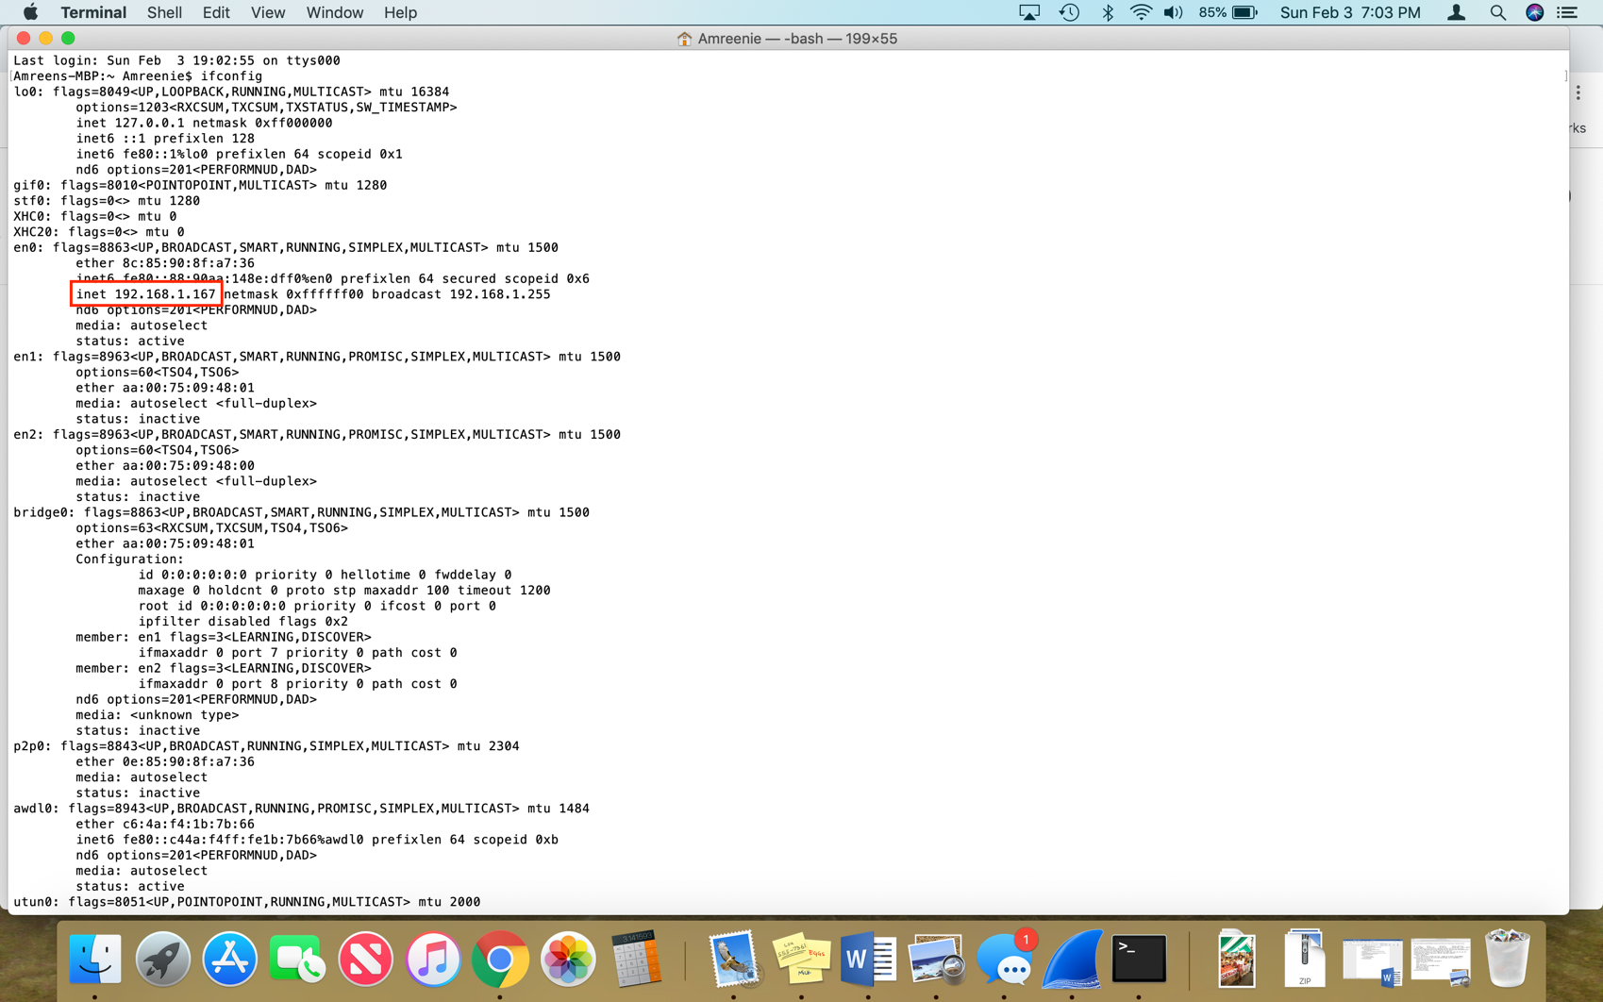

1. What is the internet address of your computer? 192.168.1.167

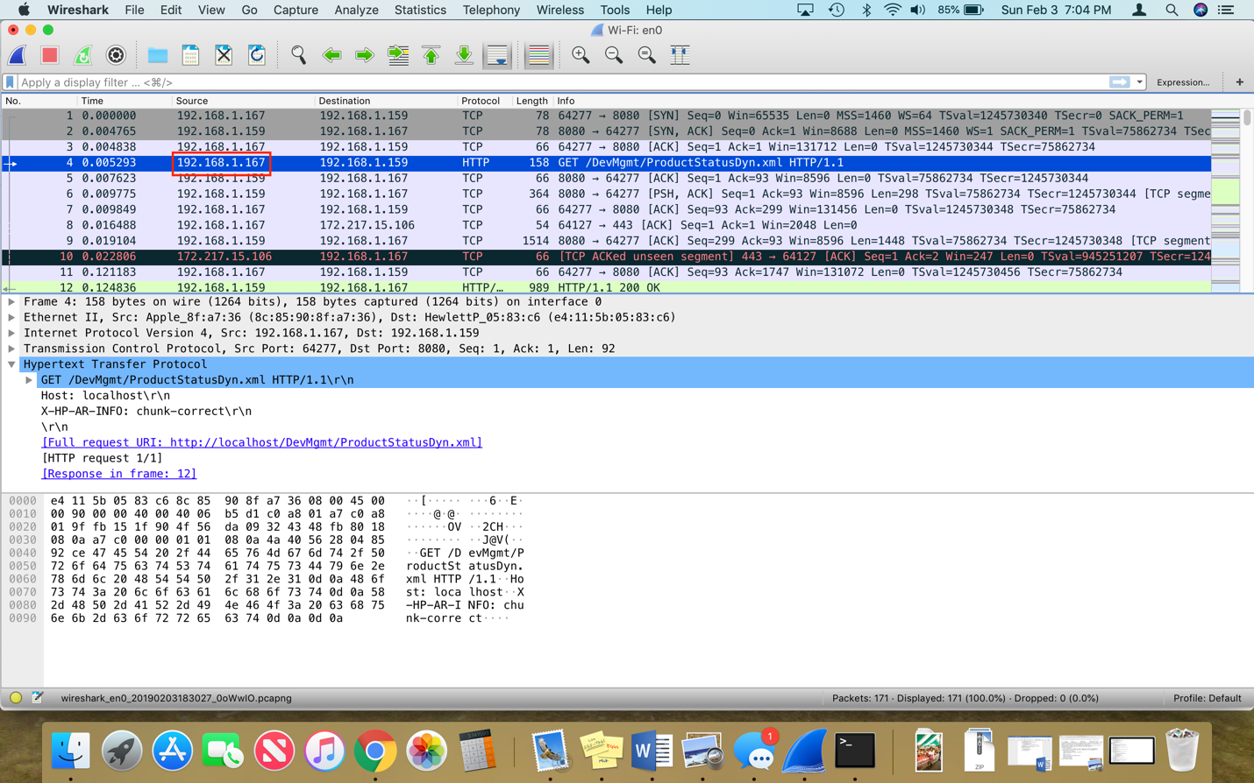

1. List 3 different protocols that appear in the protocol column in the unfiltered packet-listing window.

HTTP – screenshot 1

TCP – screenshot 2

SSDP – screenshot 3

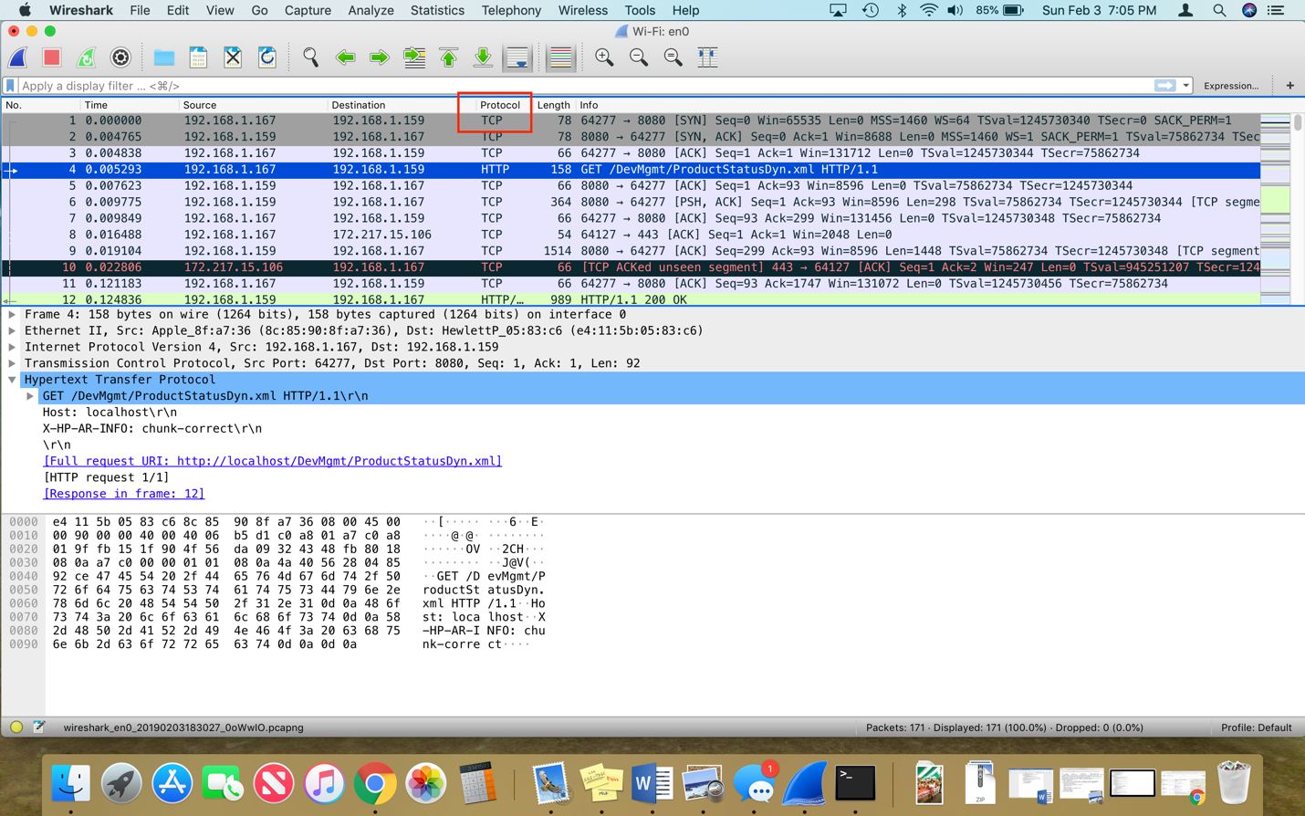

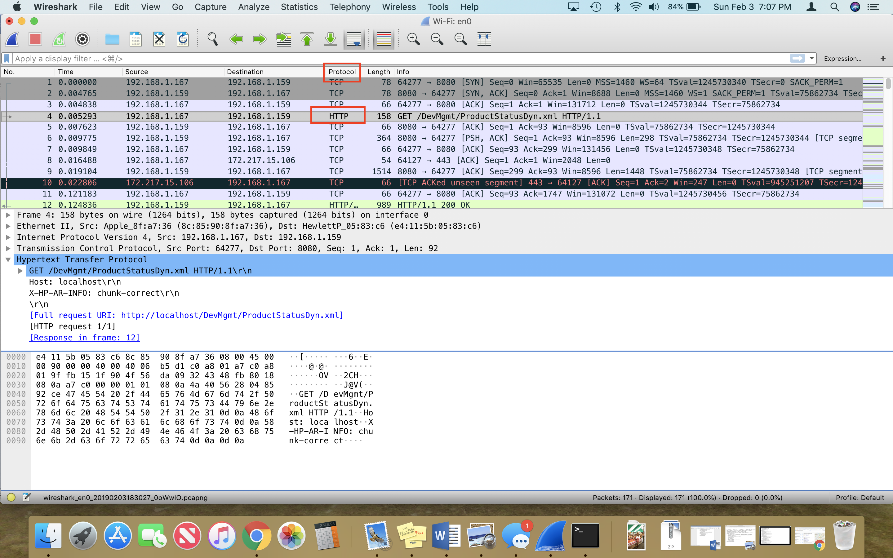

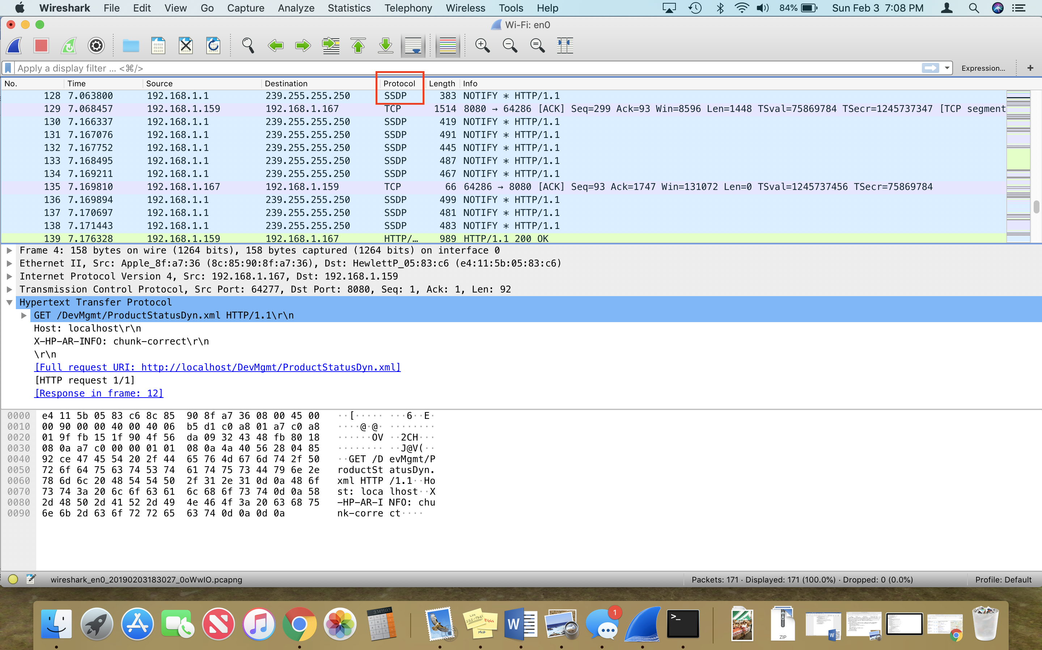

1. How long did it take from when the HTTP GET message was sent until the HTTP OK message was received? .119543 seconds

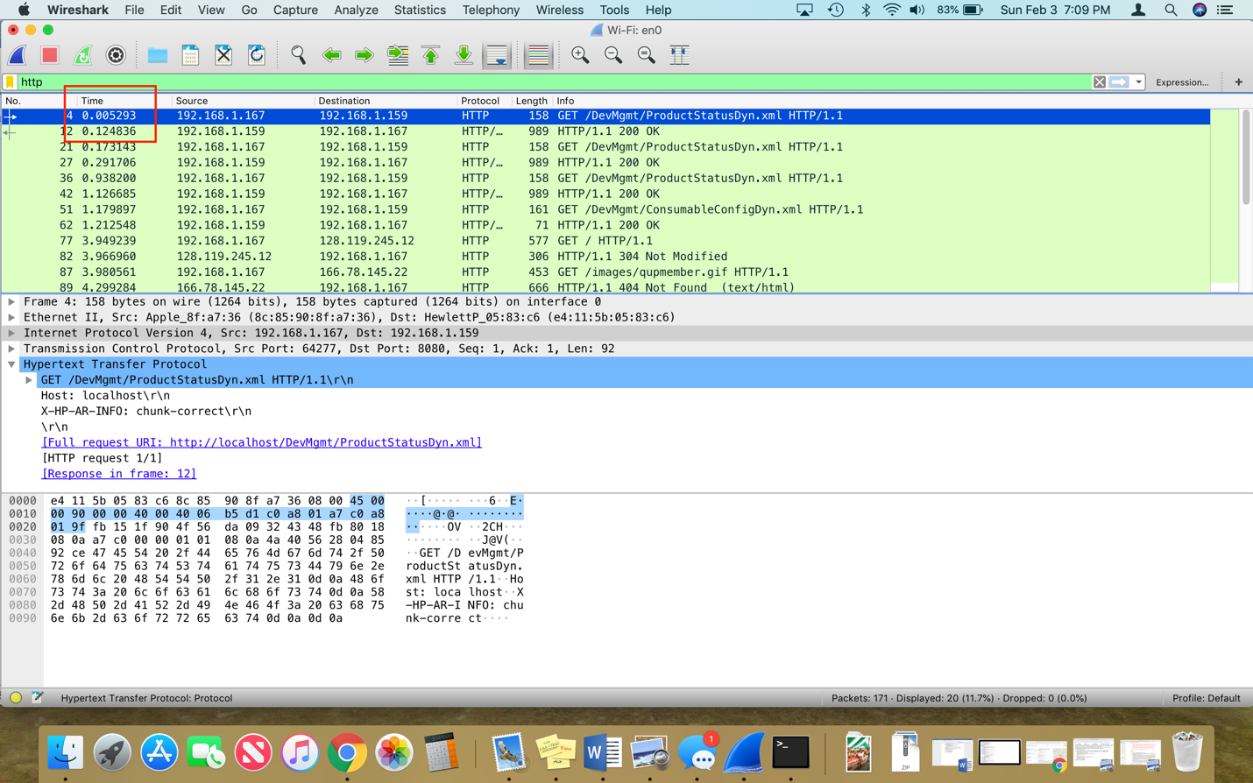

1. 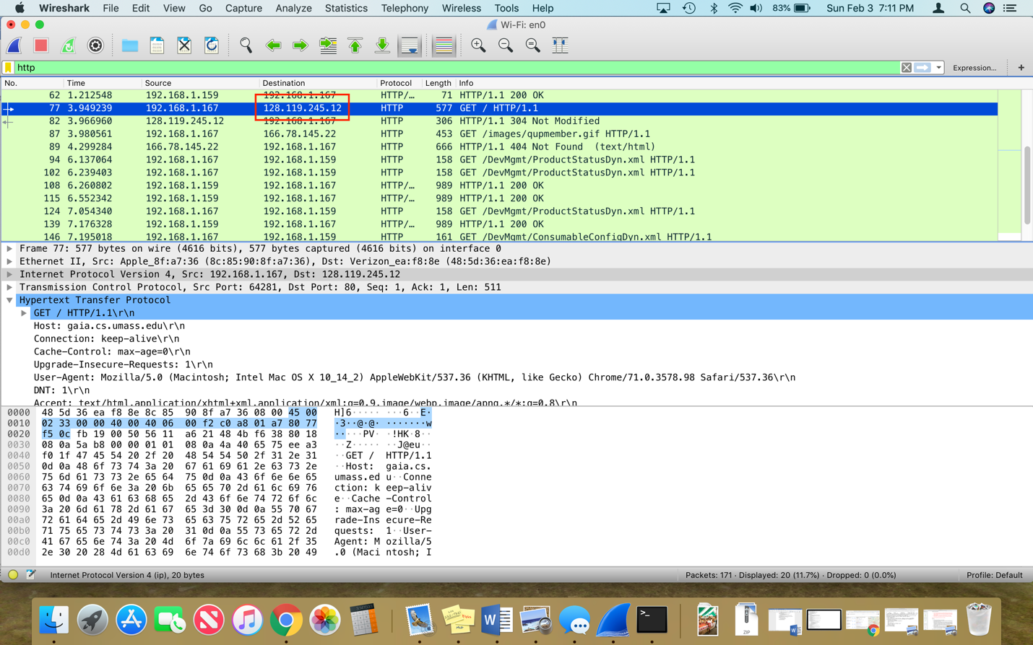What is the internet address of the website: gaia.cs.umass.edu? 128.119.245.12
2. Print the HTTP messages referred to in question 2 above. Attached in a separate PDF file and screenshotted below.

